LSTM Vanilla

The dataset used for training was taken from the INMET website with meteorological data from the station SAO PAULO — INTERLAGOS (A771) in the city of São Paulo — Brazil. The sampling frequency of the temperature data is hourly and 4 years of training from 23-March-2018 01:00 to 23-March-2021 12:00 were used.

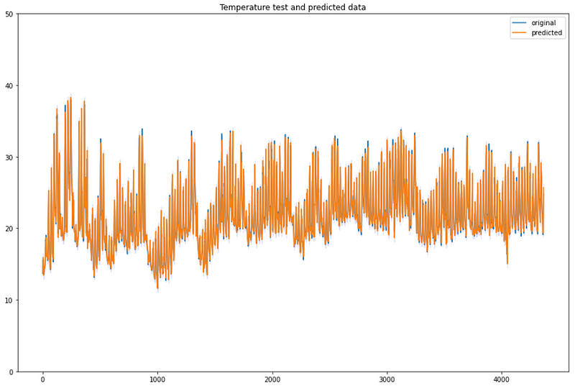

Regression metrics for the training:

* MAE (Mean Absolute Error): 0.55
* MSE (Mean Squareed Error) : 0.80
* MAPE (Mean Absolute Percentage Error): 2,5 %

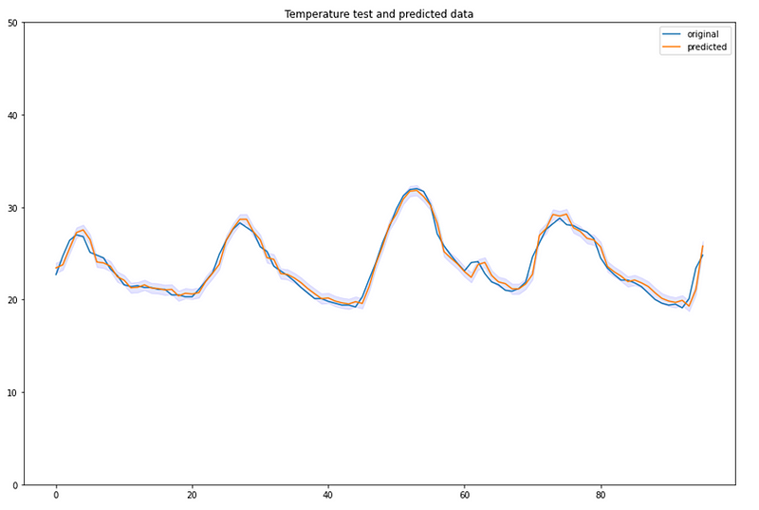

LSTM Stacked

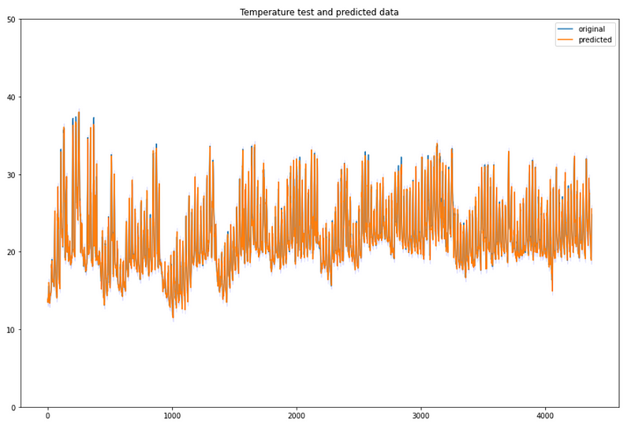

* MAE: 0.55
* MSE: 0.82
* MAPE: 2,5 %

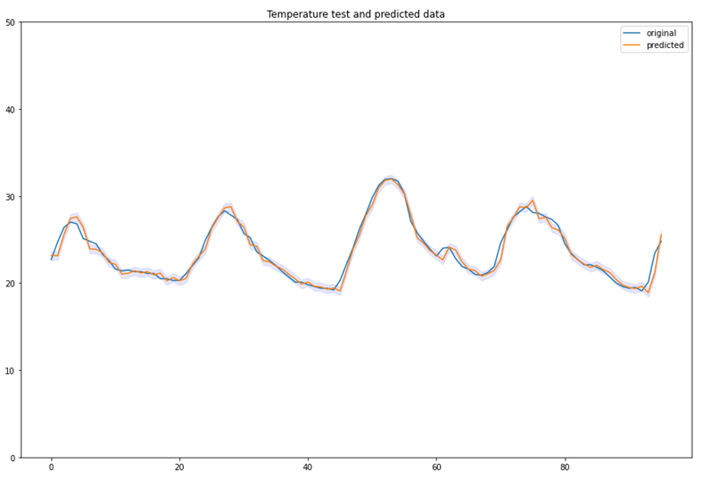

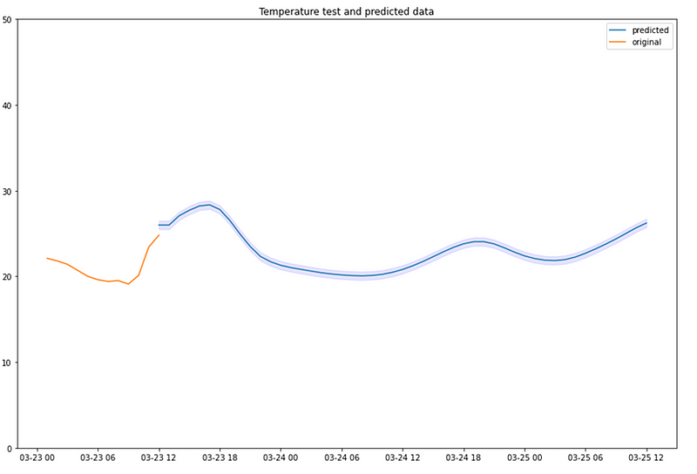

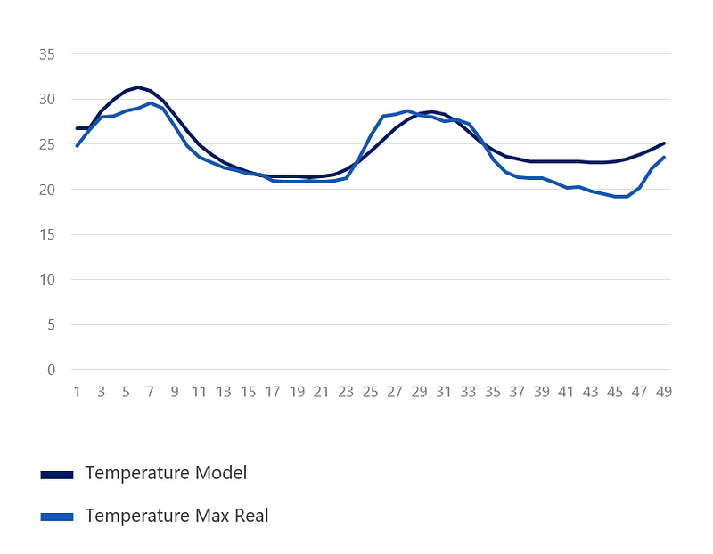

* Average error: 1,44 ºC
* Maximum error: 4ºC